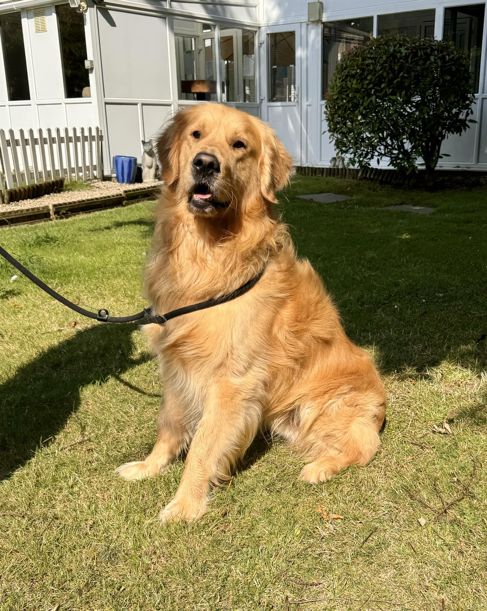

WAFFLE – AUGUST 2024

Hi everyone, let me introduce myself:
My name is Waffle, I am four years old, have golden hair, brown eyes, am an entire male and I think I am very handsome and you would think that would be all I need. However what I need more than anything is a home just like other dogs do and I believe there is a home waiting for me but I need your help, so I will tell you a bit more about myself
Until earlier this year I had a home but sadly I found myself leaving that home and the lovely people at Eastern Counties GRC offered me a place to stay in some very nice kennels, apparently lots of other lucky dogs get to stay here but I have noticed after a couple of weeks they go and more arrive, but not me
The reasons I have had to leave my home is because I am quite lively, have shown a few incidences of resource guarding and I can be reactive to other male dogs. Obviously I now see the error of my ways and really want to prove to someone that I can be better, I just need that special someone to help me.
So this is my message to anyone reading this, if you think you are that person or know someone who can offer me the guidance I need and an active lifestyle please get in touch as soon as possible because despite the wonderful care I am receiving I just want a place to call home’
Love Waffle
If you are able to help Waffle please contact our rescue officer Mike Hamilton ASAP, contact details at the bottom of this post.
Although posts from this page cannot be shared please feel free to copy and paste to help us find the home this lovely boy deserves.
Thank you

To discuss the possibility of offering Waffle a home contact our rescue co-ordinator directly at goldenretrieverrescue@hotmail.com or by phone on the dedicated rescue number 07434 615157‬

